HC 2 T4 U1
 | 題目 | 圖片
1 | Crayon, please.  Here you are. | 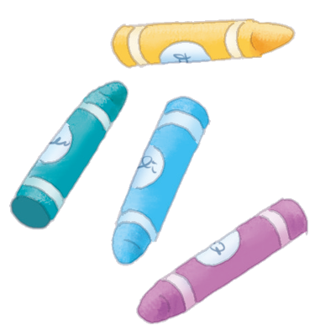
2 | Markers, please.  Here you are. | 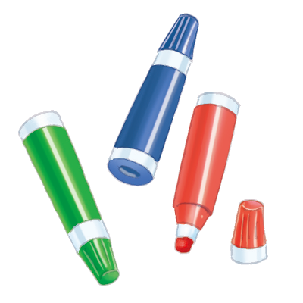
3 | Paint, please.  Here you are. | 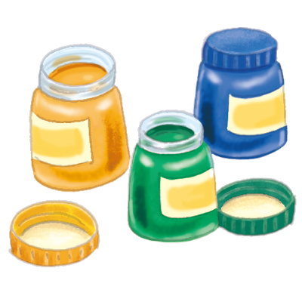
4 | Paper, please.  Here you are. | 



